# **ourDars Manual**

A Decision, Analysis and Resolution Application

[LupinCorp.com](https://lupincorp.com)

David Somerville

12 October 2019

Contents

Overview 2

Workflow 3

A: Create DAR 3

B: DESIGN 5

DAR Participants 6

DAR Criteria 8

DAR Solutions 9

C: Is DAR defined? 10

D: Is Methodology = Vote? 10

E: Evaluate 11

F: Is Methodology = Hybrid? 13

G: Vote 13

H: Confirm 15

I: Closed 16

DAR Viewer and Printing 18

My DARs 20

Logging In 21

Administration 23

Manage Users 23

User Listing 24

User Profile 24

Manage Teams 25

Manage DARs 25

Import/Export DARS 26

Technical 29

Data (Firestore Document Model) 29

Security 31

Evaluation Score Calculation 33

CMMI DAR Process Area 33

## Overview

The ourDars application implements a Decision analysis and Resolution process that satisfies CMMI-DEV requirements for a formal decision resolution process (see CMMI DAR Process Area at the end of this manual, and Wikipedia article on the [DAR process area](https://en.wikipedia.org/wiki/Process_area_(CMMI)#Decision_Analysis_and_Resolution_(DAR)). OurDars is intended as a shared enterprise application that automates the typical decision process used by the organization. It will ensure that:

* Decisions, to be made, are well defined, and the decision process can be easily followed.
* Roles involved in the decision process are clearly defined and managed.
* Alternative solutions for the decisions are clearly defined.
* Criteria for solution selections are defined.
* The solution evaluation process ensures the decision criteria are used when evaluating alternative solutions.

As well, ourDars, will ensure that decisions get performed quickly, with quality and the minimum costs to the enterprise. This is enabled by the following technology:

* Providing access to the decision process using web and mobile technologies.   
  Uses an Angular client configured as a PWA (Progressive Web Application). This technology will allow offline usage for mobile users and responsive UI for mobile and desktop use.  
  Material Design based UI to ensure a familiar and low friction user experience (See <https://material.io/>)
* Users managed and integrated with the enterprise security systems.
* Realtime and interactive collaboration during the decision process. Changes to DAR data occurs immediately and is reflected immediately in any data viewed by other people working on the DAR.
* Data managed centrally in the google cloud (No need to install on site). Uses firebase (see <https://firebase.google.com/> ) technology stack that includes no SQL firestore database , “serverless infrastructure”, supporting google services for authentication, hosting, cloud functions and monitoring. Enterprises create their own firebase instance to host their own ourDars instance both securely and privately.
* Opensource (The application is opensource see <https://github.com/somervda/ourDars> ). Users can take the source code and modify and extend as they see fit. There are no usage restrictions.
* Consulting services are available for help with getting an ourDars instance setup and running for your enterprise. Once setup it is expected that enterprises will be able to easily manage their own ourDars instance.

## Workflow

The ourDars application includes a built-in workflow to move a decision from creation and definition through to closure. The workflow includes a series of states to ensure only the DAR participants with the required roles can perform key operations (i.e. Stake owners, Evaluators etc.). The “Owner” role is a special role that oversees the progress of the DAR to completion.

See flow below for overall workflow and details on each stage.

### A: Create DAR

When the need for a decision has been identified, then ourDars can be used to define and work though the decision. Only some users will be able to create a DAR (Decision analysis and resolution document), the ability to create DARs is set up by the system administrator and will result in the user having the “Create Dar” option on their menu.

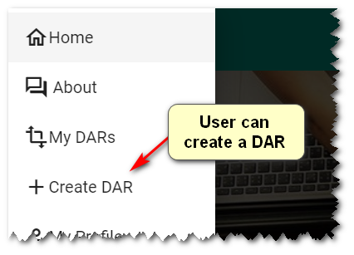

Clicking on “Create DAR” will take the user to the DAR form in create mode

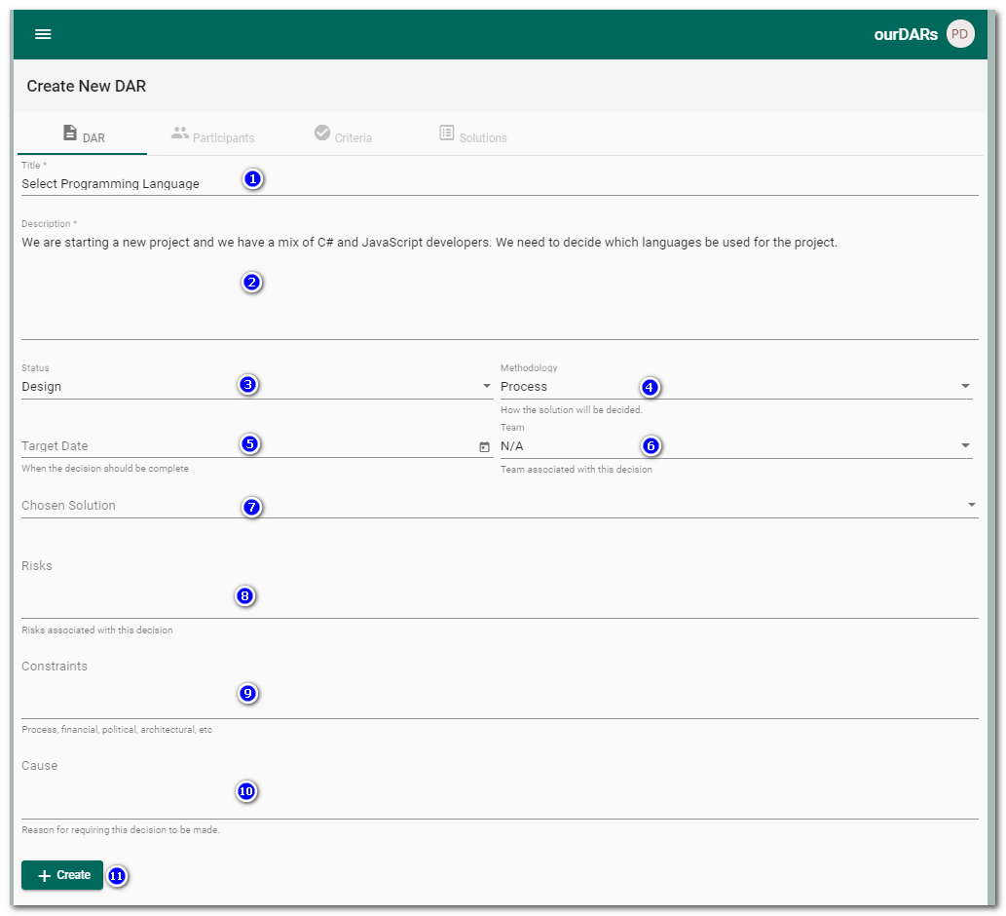

Enter the following information

1. Title: A short name for the DAR
2. Description: A full description of the decision to be made.
3. Status: Initially, when first created, the DAR has a status of DESIGN, the status cannot be changed until the workflow criteria are meet to move to the next status.
4. Methodology: Or how the DAR will be processed. The supported methodologies are:   
   PROCESS methodology will be performed using a formal evaluation of each of the possible solutions against set criteria. The solution will be decided based on the results of scoring each evaluation.  
   VOTE: This methodology will select a solution using a simple voting system.  
   HYBRID: This methodology will still perform the evaluation and scoring of solutions but the solution will still be chosen by a vote (So the highest scoring solution may not be chosen).  
   VOTING and HYBRID methodologies are known as “political” processes as factors other than strict evaluation criteria may be used in the resulting decision process.
5. Target Date: Optional – used to identify when a decision should have been completed.
6. Team: Optional – Align the DAR with an enterprise team, this will be useful to identify particular participants who should be involved in a decision and segmentation of decisions in an organization. Administrators can create teams and make users members of a team.
7. Chosen Solution: Entered by the DAR owner once a solution has been chosen by evaluation or voting.
8. Risks: Optional - Text describing any risks that need to be considered when making the decision, including choosing the wrong solution.
9. Constraints: Optional -Text describing constants on the decision-making process or solution choices. These may become constants for the evaluation process (i.e. budget, time, etc.)
10. Cause: Optional -Text describing why this decision is required and what triggered the need for a decision to be made.
11. Create: Pressing this will create the DAR and set the current user as the owner. A title and description must be entered before this button becomes active. If successfully created, the user will be returned to their “My Dars” page and new DAR will be in their My DARs list.

### B: DESIGN

When the DAR is in DESIGN mode then the owner can make changes to the definition of the DAR including; Participants, Criteria and Solutions. In the DAR workflow, if changes are needed then the DAR must be returned to the DESIGN status. The DAR can only move forward from the DESIGN stage when all required elements are present (See C: Dar is defined?). The following describes how the participants, criteria and solutions are defined for the DAR.

The DAR owner can update the DAR by finding the DAR in the MY DARs listing and selecting the “Edit”

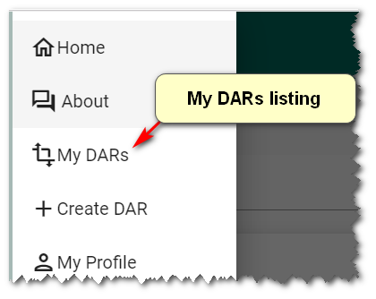

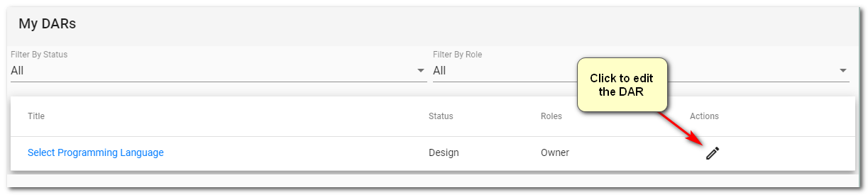

Once the edit action is selected then the user is returned to the DAR form, the original information can be updated as well as changes made to the participants, criteria and solutions.

#### DAR Participants

DAR participants are the users who are involved in the decision process. Any user who is a participant will have visibility to the DAR (Will show in their My DARs listing) and may have other rights depending on their role on the DAR.

To edit the participants, go to the DAR form, and click on the “Participants” tab. See resulting view below

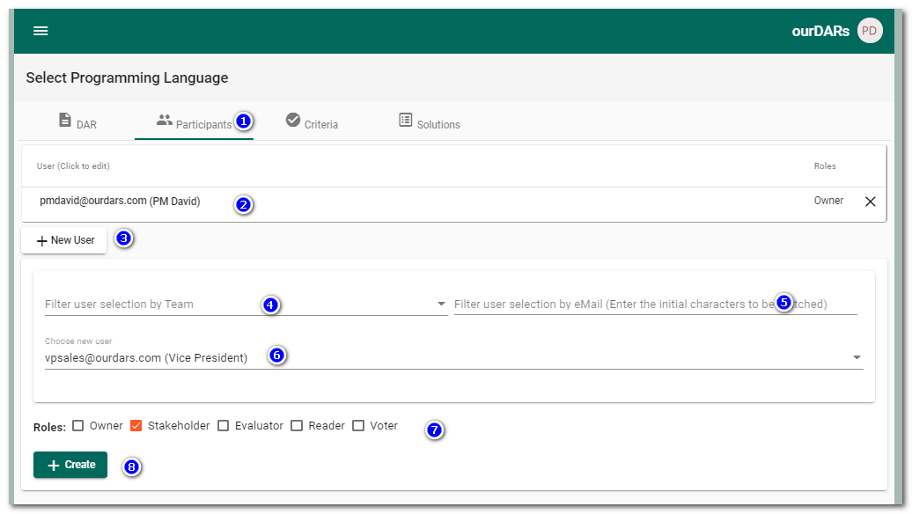

In the participants tab the user can; Create a new participant, edit a participants roles or delete the participant. Form fields are:

1. Participants Tab – Click to open the participants view.
2. List of users who are current participants in the DAR process. By default the person who created the DAR will be in the list with the role of OWNER.  
   Click on the User’s email to edit a user’s role, click on the X to remove a user as a participant, or click on the “New User” button to make a user a new participant.
3. New User – Click to create a new DAR participant.
4. Filter list of users (6) by team. Use of this is optional but for large organizations will make finding users, easier, by segmenting them into teams (i.e. Finance, ProjectX , etc.).
5. Filter list of users (6) by their email. A simple filter on the email of users. i.e. enter “Da” will only find users with emails that start with Da.
6. Choose new user – A drop down list of users (filtered by filters 4 & 5). Select a user from the drop down.
7. Roles – The DAR roles to be assigned to a participant. Participants can have multiple roles (i.e. be a Voter and an Evaluator).
8. Create – Once the participant has be selected and roles chosen then this will add the user to to participant list.

See an example of a list of participants list below (Note: The user signed in cannot delete their own participant record).

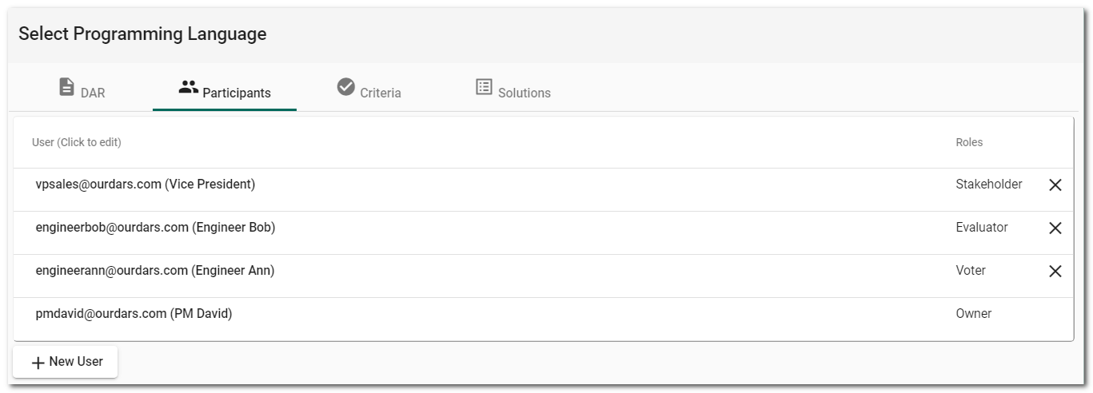

#### DAR Criteria

At least on criteria must be defined for use in selecting a solution. The criteria for a DAR can be edited by going to the DAR form and selecting the criteria tab (see DAR criteria form below.)

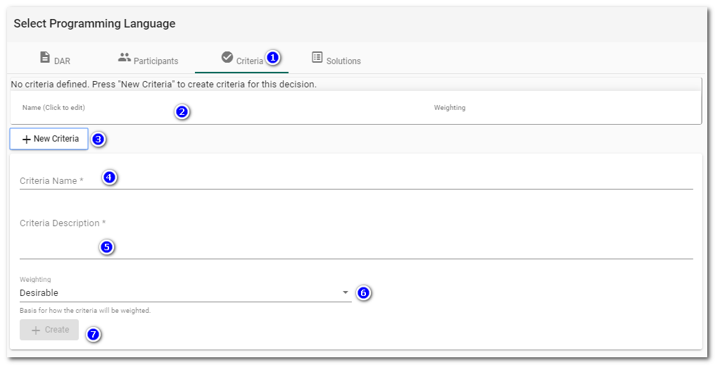

1. Criteria Tab – click to enter the criteria editor. This form can be used to create, update or delete criteria for the DAR.
2. List of criteria for the DAR. As criteria are created they will be show in the list.
3. New Criteria – This button will open a form below it where new criteria can be defined.
4. Criteria Name – a short name for the criteria.
5. Description – a longer description of the criteria and any additional information such as how the criteria is to be evaluated.
6. Weighting – the importance of the criteria that will be used to derive the evaluation score. The weightings available are ; CRITICAL, IMPORTANT and DESIRABLE.

An example of a set of criteria for a DAR is shown below.

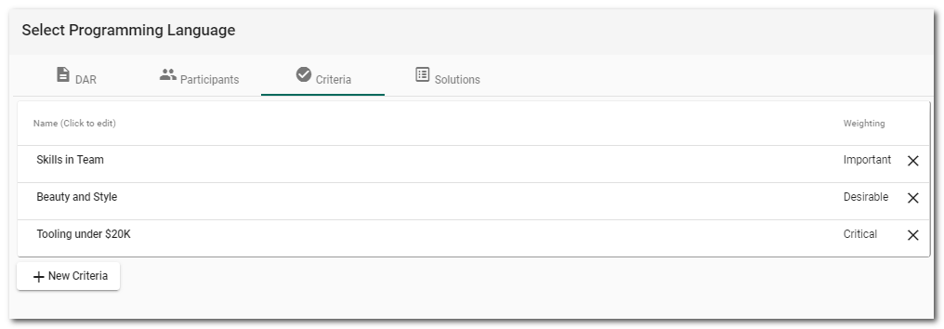

#### DAR Solutions

The solution editor for a DAR is found under the “Solutions” tab on the DAR form (See Solutions form below).

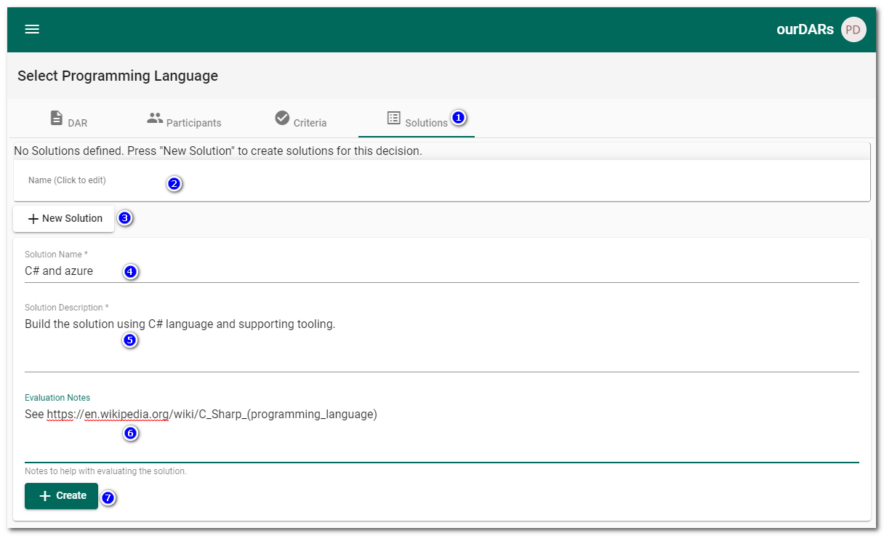

The DAR editor can be used to create, update and delete solutions for a decision.

1. Solutions Tab – Click to view the solutions editor.
2. Solutions List – A list of solutions for the DAR.
3. New Solution – Click to create a new solution.
4. Solution Name – A short identifier for the solution.
5. Solution Description – A full description of the solution.
6. Evaluation Note – Notes used to help the evaluator or the solution. i.e. Links to more information about the solution, where to get the solution (URL?) or people to contact for the solution.
7. Create – Press to add the solution.

See example of a Solution listing below.

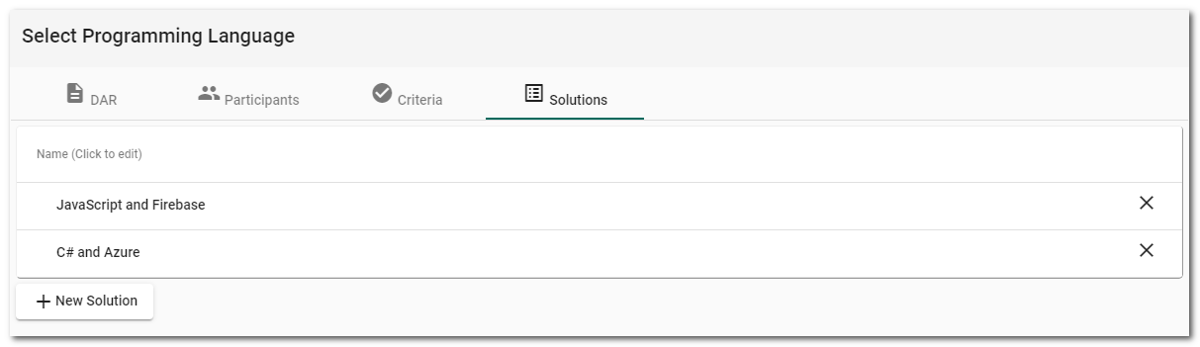

### C: Is DAR defined?

The DAR form and DAR viewer will show information about the next available status and any actions needed before a DAR can be moved to the next workflow status. During DAR creation (DESIGN Status) certain DAR elements (Participants, criteria and solutions) must be defined before the DAR can move forward. Below, an example of the type of status information shown.

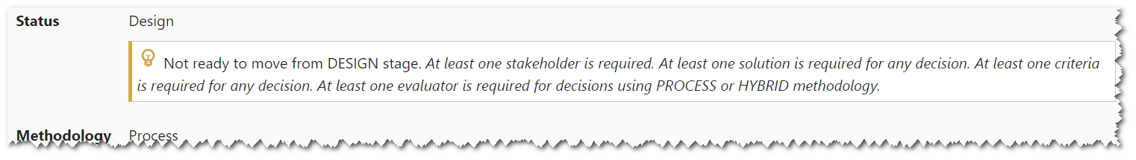

### D: Is Methodology = Vote?

Depending on the selected methodology the DAR will be evaluated (PROCESS, HYBRID) or voted upon (VOTE). The owner of the DAR needs to update the next status but will be restricted in choices based on the selected methodology.  
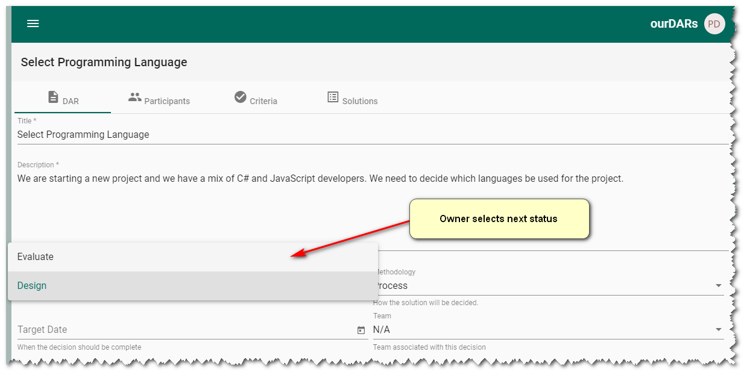

### E: Evaluate

When in the EVALUATE state, users with the EVALUATOR role, can enter details about the evaluation of each solution against each criteria. Evaluators will identify DARs ready for evaluation in their “My DARs” listing and there being an Evaluation icon in the actions for the DAR. See example below.

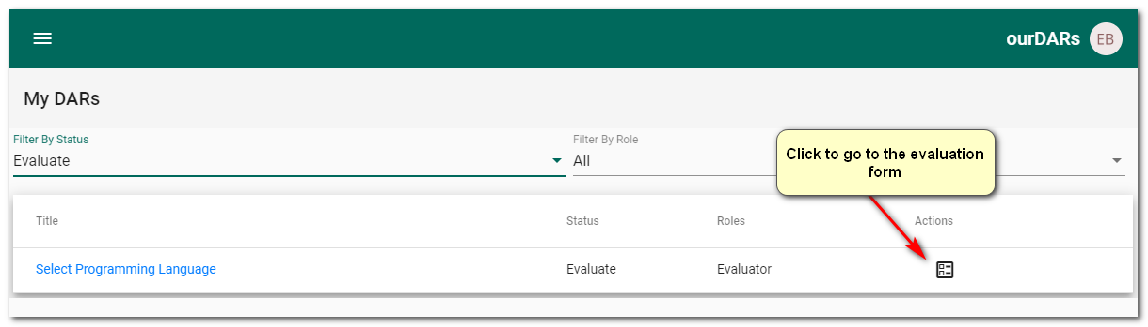

Clicking the Evaluation action will open the evaluation form for the DAR (See above). Initially this is shown as a list of solutions for the DAR, with an expansion arrow next to each solution.

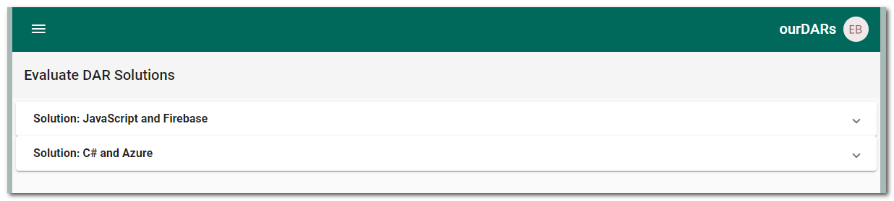

Opening one of the Solutions will display a form that allows the evaluator to enter an evaluation for each criteria for that solution (See example below with the C# solution opened)

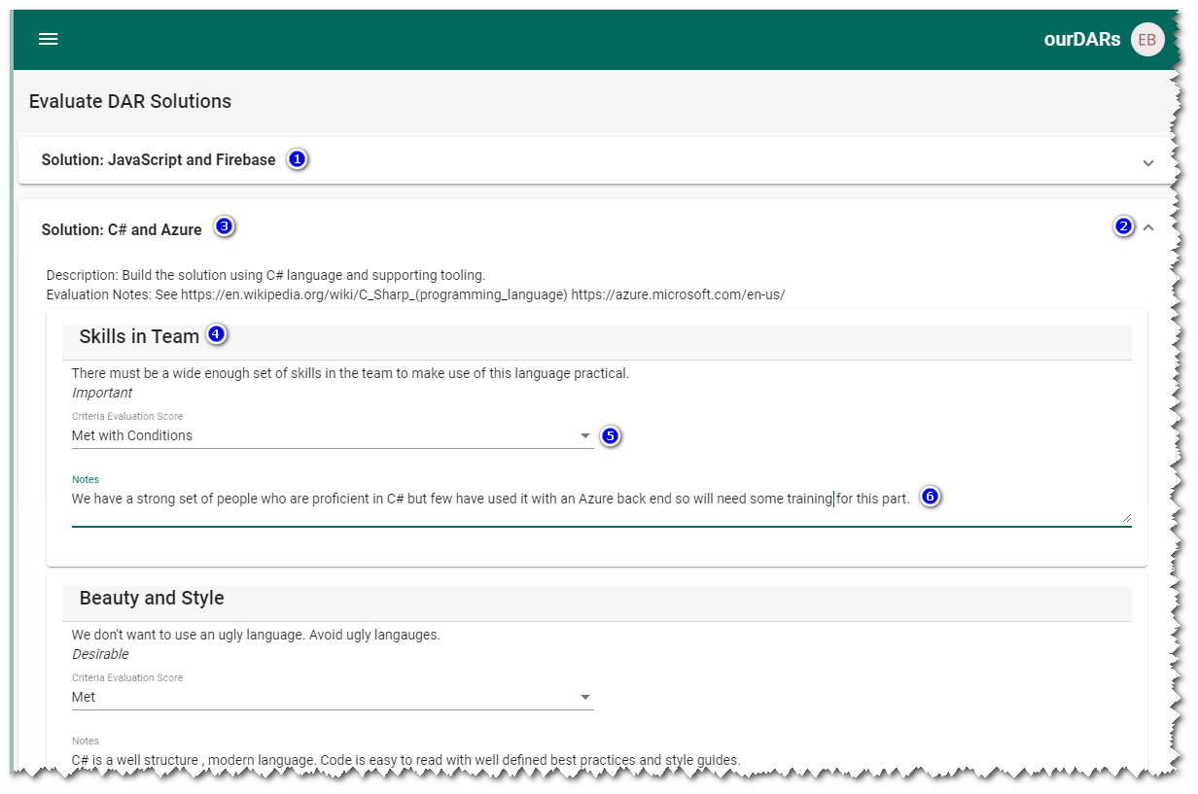

The details of this evaluation form are:

1. Each solution is presented as an line item that can be expanded to allow the entry of evaluation details.
2. The example shows the “C# and Azure” solution opened.
3. The Open/Close control for a solution. Note: Only one solution can be opened at a time.
4. The criteria for the DAR will be presented as separate “cards” for each criteria in the solution.
5. The score (How well the criteria is met by the solution). The evaluator selects the appropriate score. The available scoring options are “Fully Met”, “Met”, “Met with conditions”, “Partially Met” and “Not Met”
6. Notes – A area for the evaluator to describe in more detail how they determined the evaluation score.

The evaluation form is fully interactive (Data is updated as entered) and changes displayed in real-time for other DAR participants. If working with other team members then changes can be made and viewed, collaboratively, by all team members in real-time.

Note: Non-evaluators can also view the evaluation process (And resulting solution scores) on the DAR Viewer (See DAR Viewer section)

Once all evaluations are complete, the DAR owner should be informed. The owner will review the evaluations will move the DAR to the next status. (See G: Is methodology = Hybrid?)

### F: Is Methodology = Hybrid?

This is a workflow checkpoint for the DAR owner. If the DAR is using a HYBRID methodology then the owner will move the DAR to the VOTE status. If the DAR is using the PROCESS methodology then the owner will enter the “Chosen Solution” in the DAR based of the solution with the highest evaluation score, and then move the DAR to the CONFIRM status.

### G: Vote

Voting is performed by voters when the DAR has a status of Vote. DARs will have a Vote status when either

1. The DAR methodology is VOTE, in which case the Voting can be performed straight after the design stage. No formal evaluation of solutions is performed.
2. The DAR methodology is HYBRID and the evaluation stage is complete. In this case the voters can use the evaluation information to inform their votes.

Voters will be able to vote by entering the “My DARs” form and clicking on the Vote action for the DAR to be voted on.

Note: In this example I added a voter to the participants and changed the methodology to HYBRID to have a voting stage.

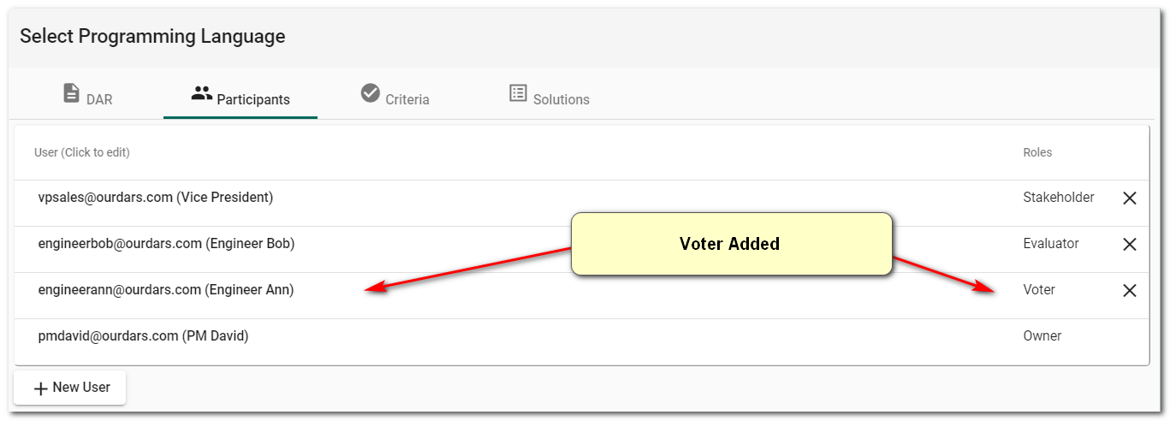

The Voting option can now be selected from the “My DARs” list.

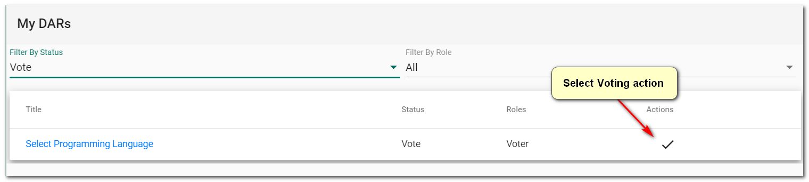

This will take the user to the Voting form (See below).

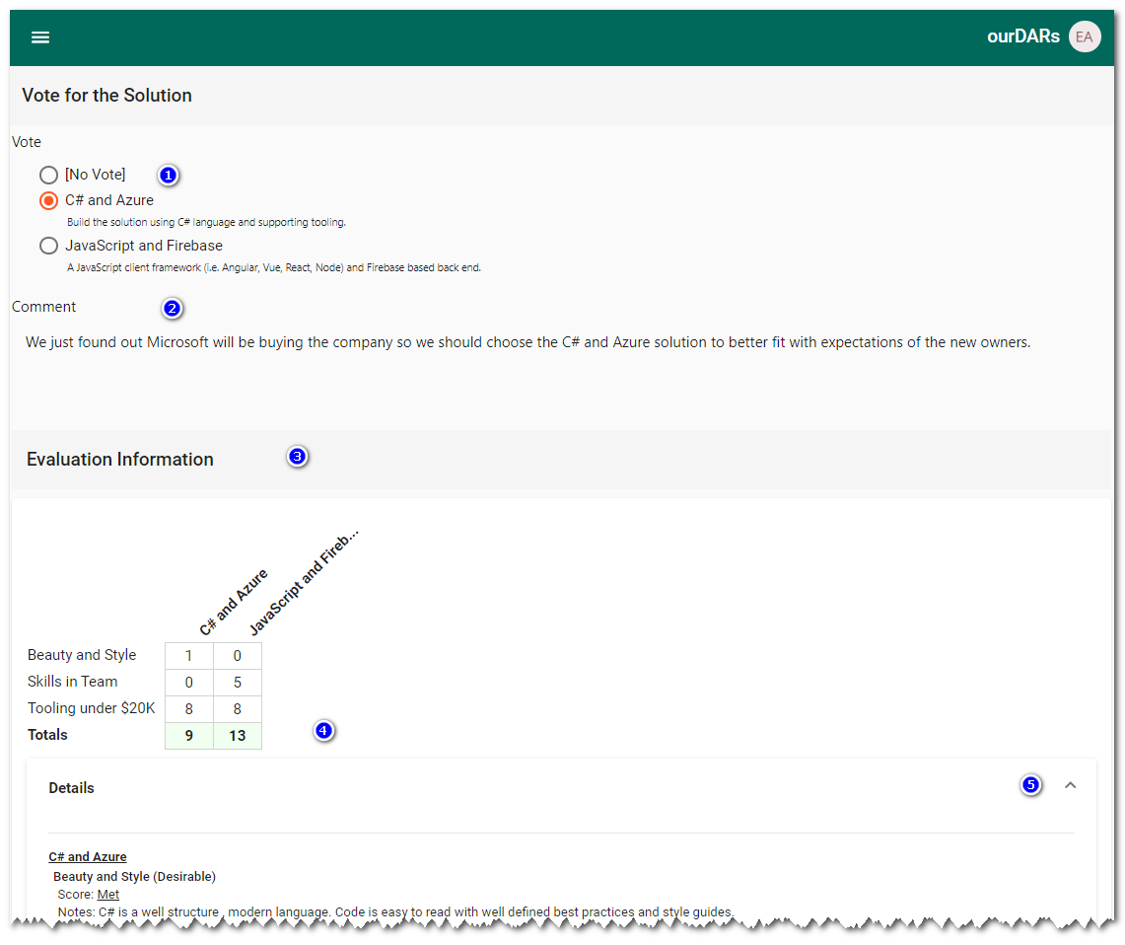

The voting form displays

1. A list of solutions that are candidates for voting (Including the option of “No Vote”). The voter checks the solution they wish to vote for. (Updates are immediate)
2. Vote Comment – Optional – add a comment about why the voter selected the solution. This is very important in the case when the voter selected a solution that did not get the top evaluation score or voted based on information that others may not be aware of.
3. Evaluation information is available for the voter to review if the DAR methodology is HYBRID.
4. Evaluation information includes the weighted scores (See Technical – Evaluation Score Calculation to see how these are calculated)
5. Evaluation details are also available for each solution and criteria. Click the Open/Close icon to see the details.

Once the voting is complete the DAR owner will review the votes in the DAR Viewer and enter the “Chosen Solution”, based on the solution with the most votes, in the DAR form and move the DAR to the CONFIRM status. (See below)

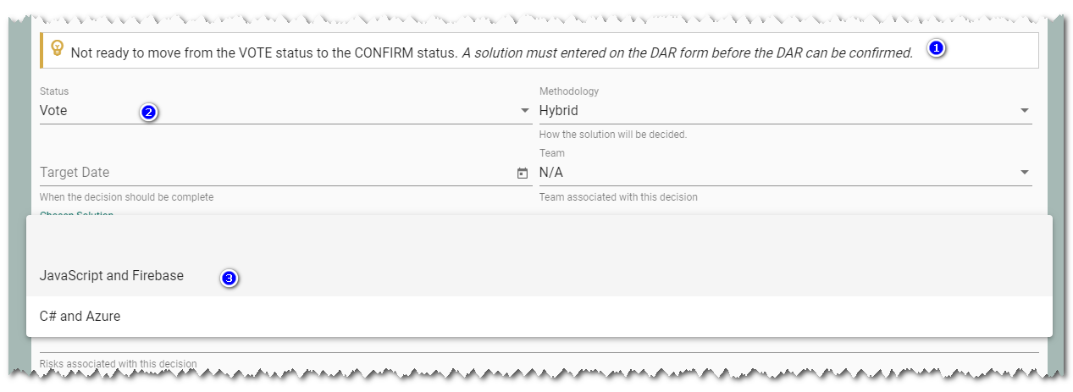

1. Message letting the owner know that a “Chosen Solution” must be selected before the status can be moved to CONFIRM.
2. Current status VOTE
3. Chosen Solution – owner should select the winner of the vote.

### H: Confirm

Once the DAR “Chosen Solution” is entered by the owner the DAR will be set to the CONFIRM status to be reviewed by the stakeholder(s) of the DAR to show that they are in agreement with the Chosen solutions (And process to get to the solution).

The stakeholders will see DARs that are ready for confirmation in their “My DARs” listing. Click on the “double check” action to go to the confirmation form.

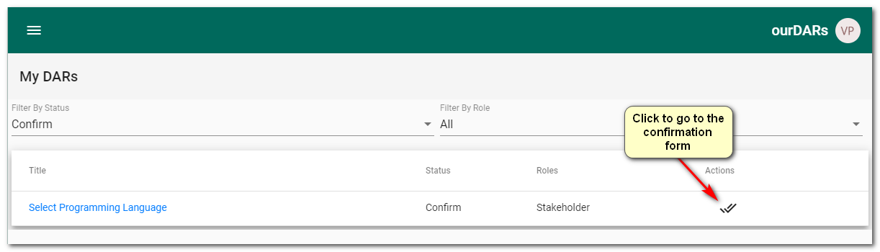

The confirmation form is shown below

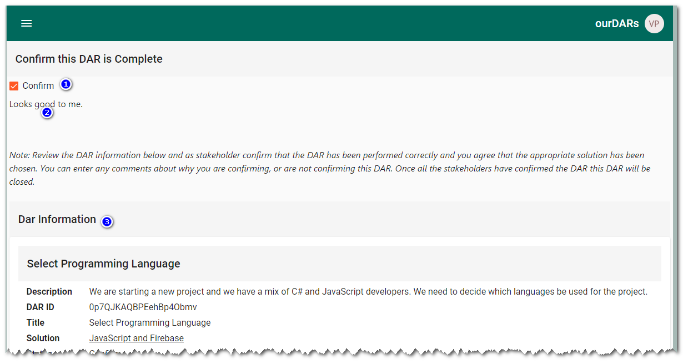

1. Checkbox to indicate if the stake holder has confirmed that the DAR is complete and can be closed.
2. Text area where any comment can be added.
3. DAR Information : All the DAR details available for review by the stakeholder doing the confirmation.

### I: Closed

The final status of a DAR. This can only be set by the owner once all the stakeholders have confirmed the DAR is complete. Until all the stakeholder have confirmed the DAR, the following message is shown (See below).

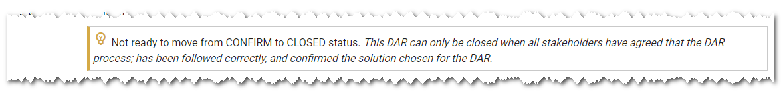

Once closed the DAR will not be shown on participants “My DARs” listing unless the CLOSED filter is explicitly selected.

## DAR Viewer and Printing

The DAR viewer provides a record of the complete DAR. This view is available to all DAR participants and is updated in real time for use in collaborative activities. The DAR viewer can be reached from the “MY DARs” listing and clicking on the title of the DAR to be viewed.

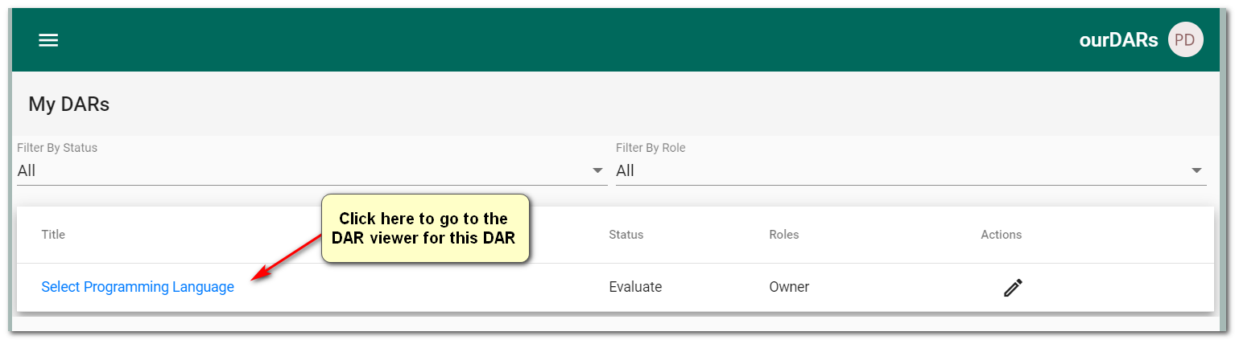

An example of the DAR view can be seen below. This view has also been optimized for printing. To print, right click in the DAR View and select “Print”

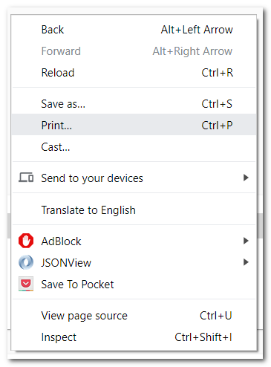

Example of a DAR View

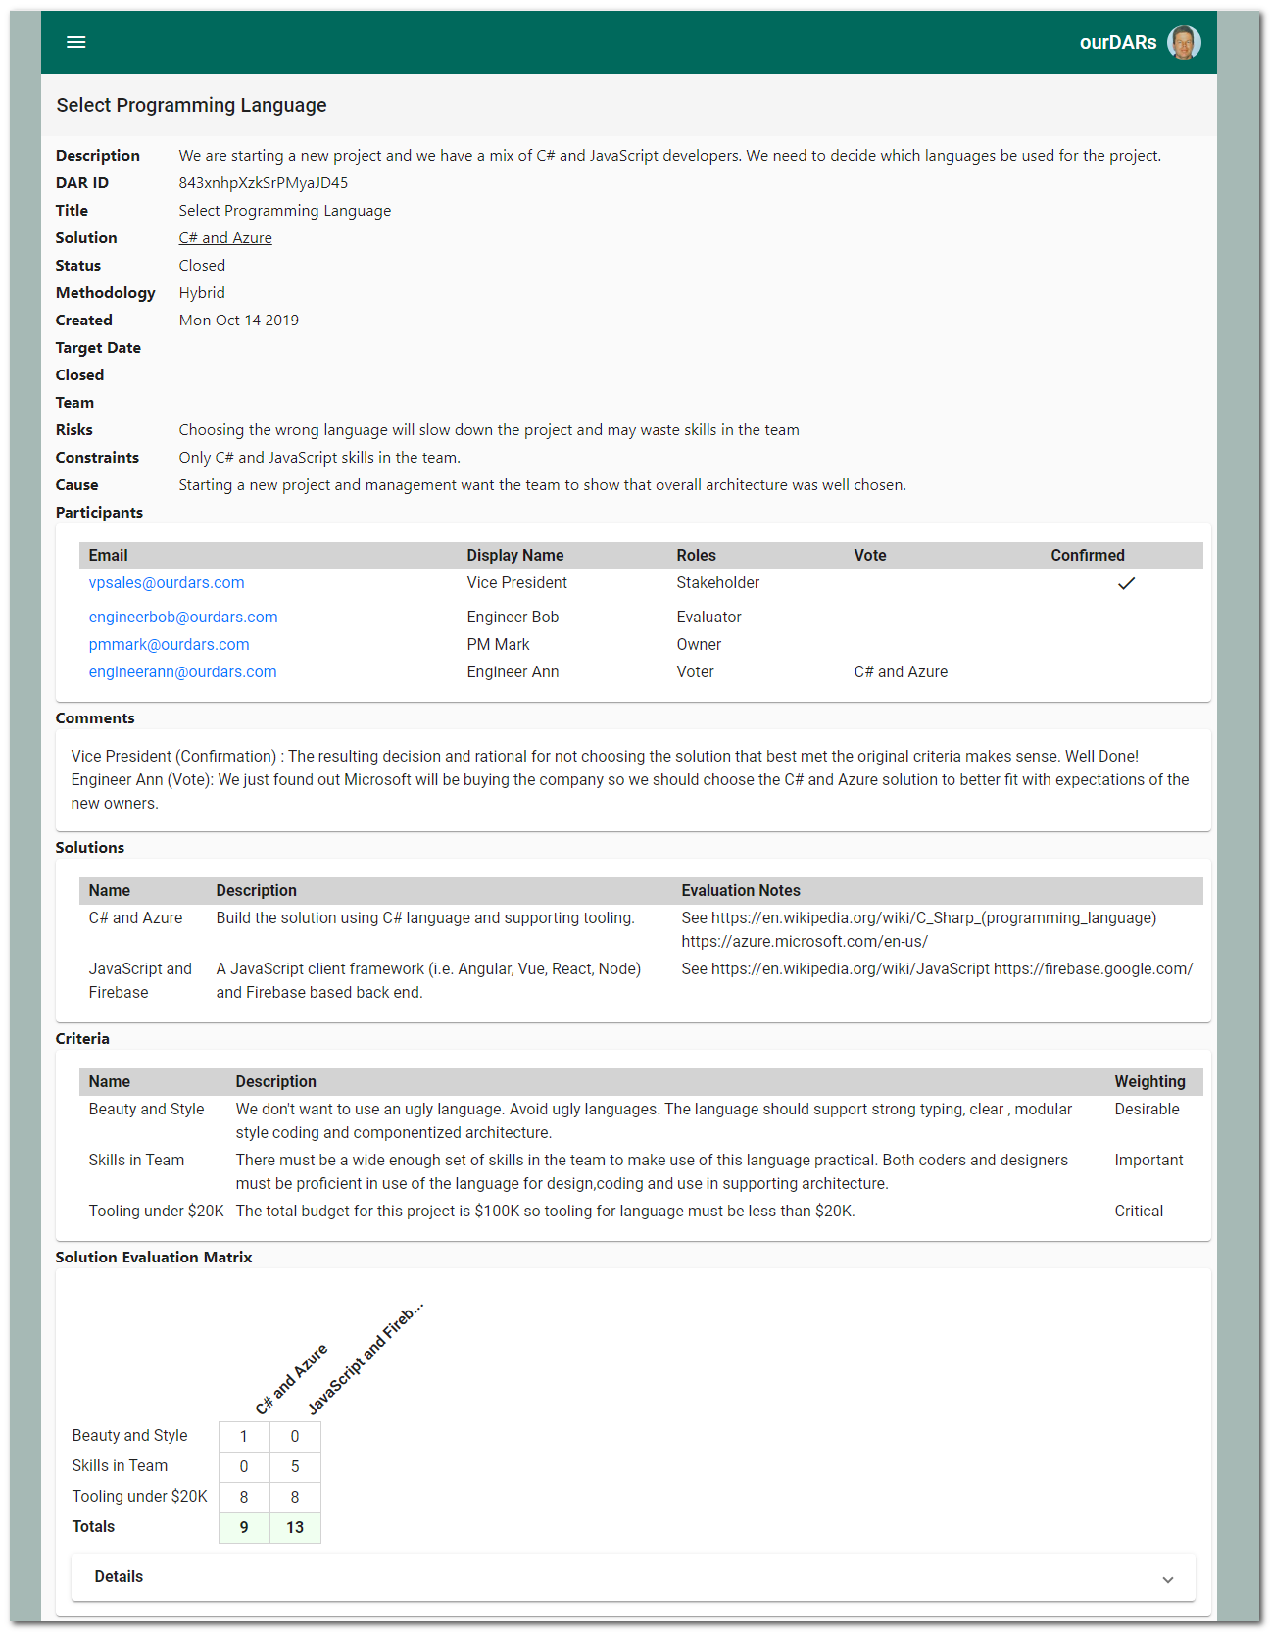

Example of the Printing option in Chrome and typical printing options

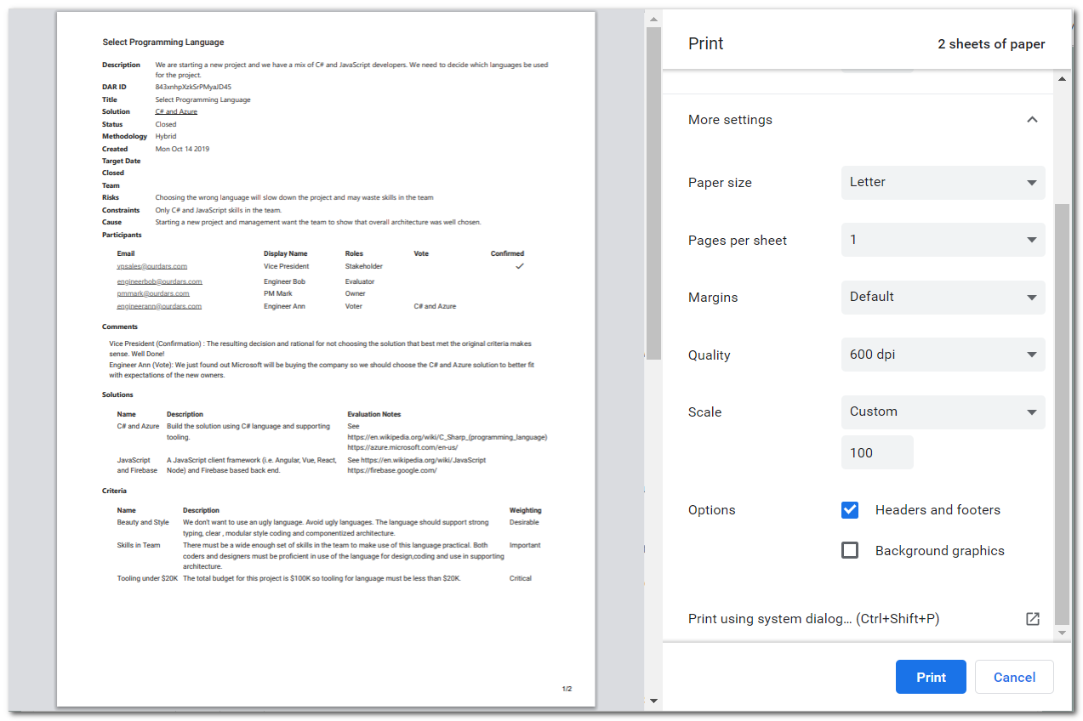

## My DARs

The “My DARs” is a list of DARs that the logged in user is a participates in completing. The “My DARs” view can be reached from the main application menu.

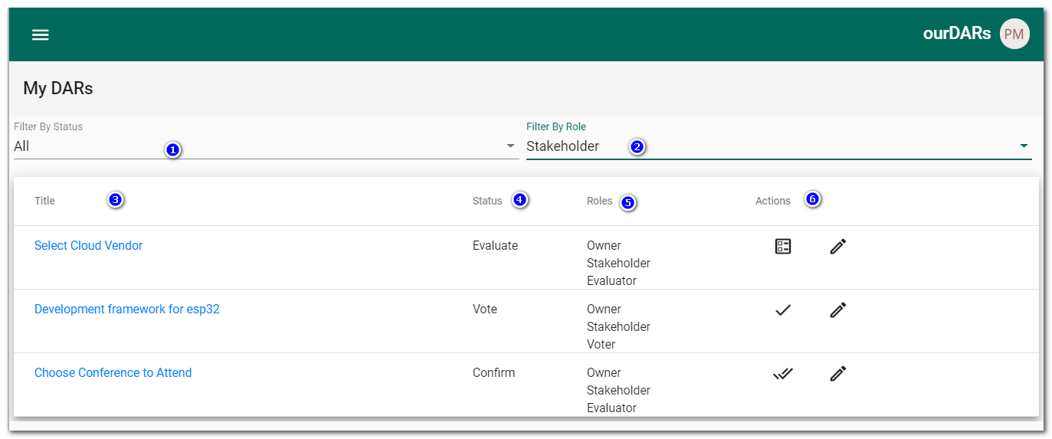

An example of a DAR listing is shown above. By default, only active DARs are shown. Form components are:

1. Status Filter: Used to either  
   - show only DARs with an active (CREATE, EVALUATION, VOTE,CONFIRM) workflow status.  
   - or show non-active DARs with the status of CLOSED or DELETED.
2. Role Filter: Used to show only DARs where the user has a specific role.

Listing Elements

1. Title: The short title of the DAR. Click the title to navigate to the DAR Viewer (See DAR viewing and printing)
2. Status: The DAR status
3. Roles: The roles the user has been assigned for participation in the DAR process.
4. Actions: The actions that are available (If any) based on the users’ role and the current DAR status. The actions are represented by an icon (Roll over to see a description of the action. An action will not be available until the DAR has reached the appropriate status in the workflow (i.e. Voting can’t be performed until a DAR has reached the VOTE status).

## Logging In

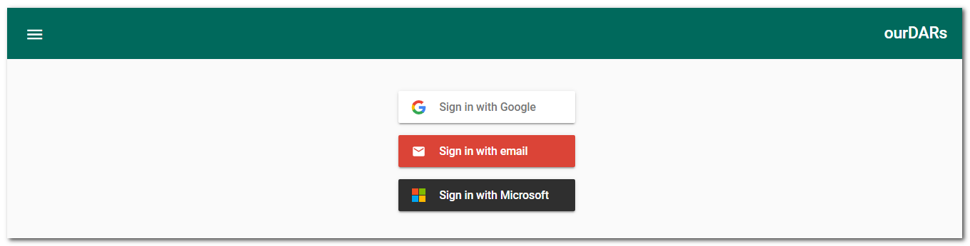

OurDars includes, out of the box, implementations of three login providers enabled by Firebase authentication services (Google, Email and Microsoft). The log-in form is the starting point, then the appropriate provider is selected. In enterprises it may be more typical for the unused providers to be removed so only the supported sign in processes is available (Usually only one is used inside an enterprise). See more about available authentication providers at <https://firebase.google.com/docs/auth> .

Typically, a user will choose the log-in method, they will be taken to the authentication providers authentication service (ourDars does not see users’ passwords etc.) and enter their user code and password. See example below for a Microsoft sign in.

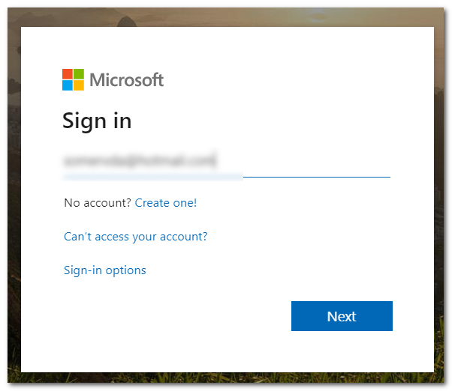

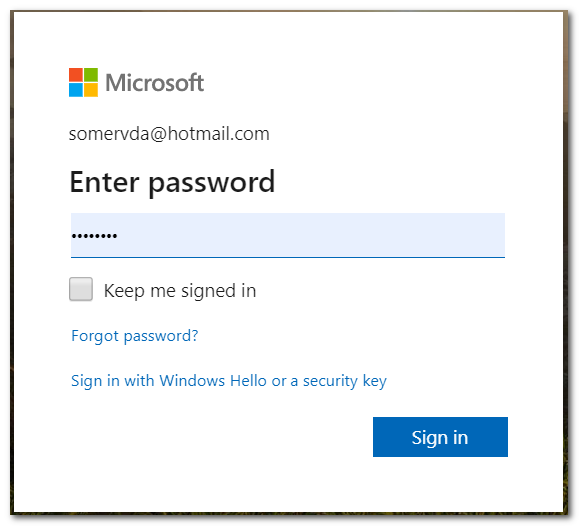



The first time a user logs into ourDars they need to be activated by a system administrator (See administration), to have access to the ourDars system.

## Administration

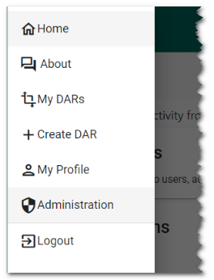

Users who are designated as administrators (see Manage Users below) have access to the ourDars administration functions. They will see the “Administration” option of the main site menu (see example to the left). Selecting Administration will take the user to the administration menu shown below. From this point they can; Manage users, Manage Teams, Manage DARs and import DARs to the system.

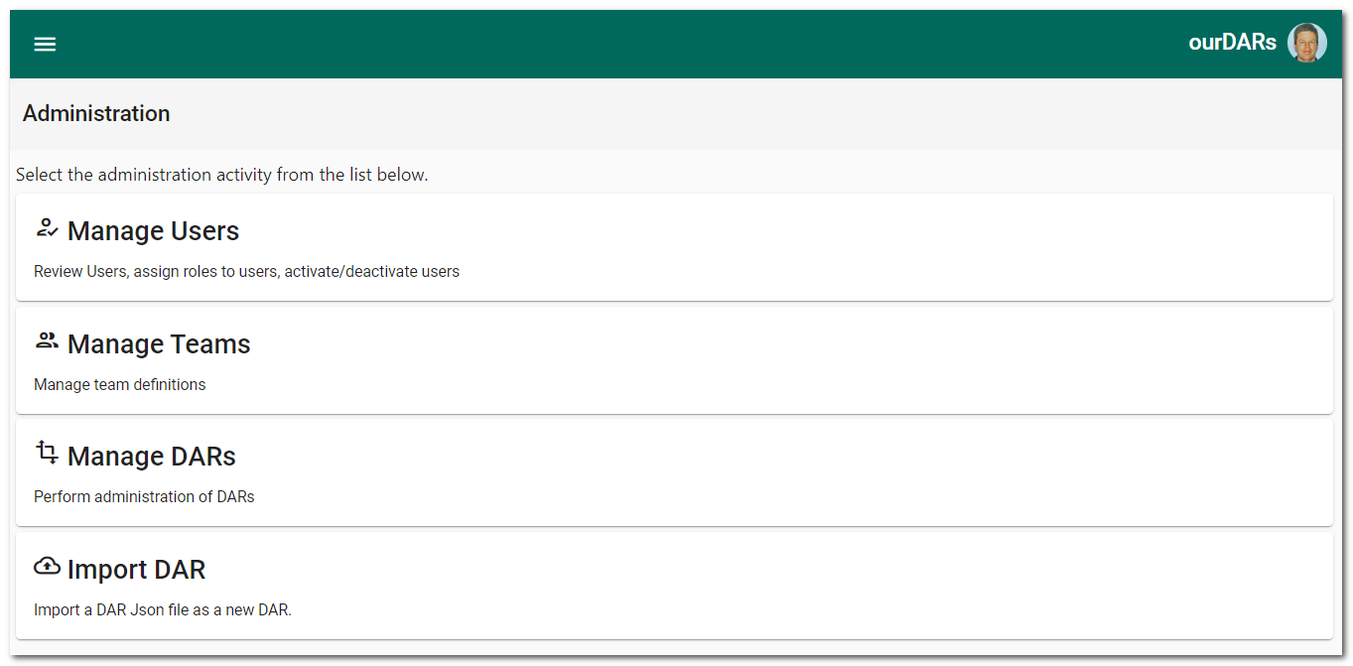

### Manage Users

Select “Manage Users” and a list of all users in the system will be shown (see below)

### User Listing

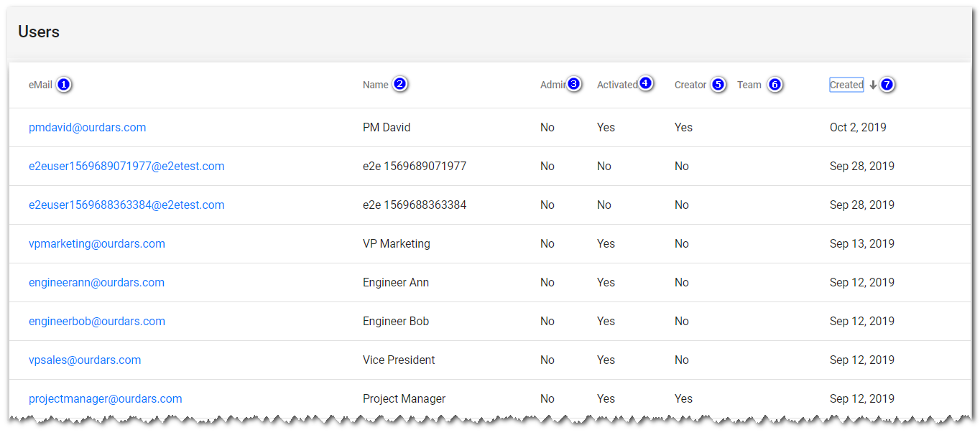

The following information is shown about each user

1. Email – This is a main identifying information for the user (Must be unique), this column is sortable by clicking on the heading. Clicking on an email address will take the administrator to the User Profile form (See below) where they can update information about the user.
2. Name – the user display name (sortable).
3. Admin – Indicates if the user has system administration rights.
4. Activated – Indicates that the user access to ourDars is confirmed.
5. Creator – Indicates if the user can crate DARs.
6. Team – The team the user is a member of (i.e. finance, IT Operations, etc.) – Sortable
7. Created – The date and time the user first logged into ourDars. This is useful for finding new users.

#### User Profile

The user profile form will be shown when navigating from the User Listing. (see example below)

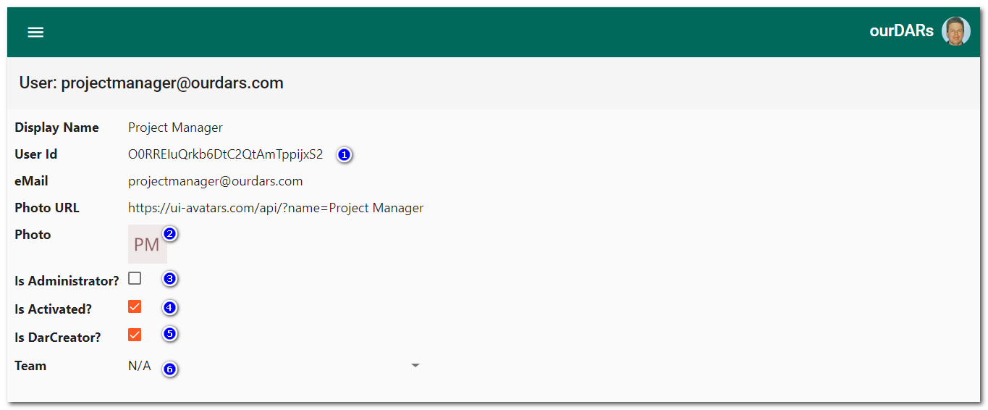

The administrator can view and update the following properties of a user.

1. User ID – The internal Firebase identifier for the user (Useful if performing Firebase administration or Firestore maintenance).
2. Photo URL information, this is usually loaded from the original authentication system (i.e. Google logon) when the user first logs in. If changes are required, this can only be done directly in Firestore.
3. Is Administrator? This is a check box used to assign/remove system administration privileges to a user. (Note: Administrators cannot update their own profile).
4. Is Activated? – Is a checkbox to indicate that a user has access to the ourDars system. This is used by the administrator to confirm a user’s access after they have first logged into the system. It can also be used to remove old user’s access to the system (i.e. left the company).
5. Is DarCreator? – Is a checkbox used to give a user the ability to create new DARs. This is usually a restricted activity – i.e. an enterprise may have a policy that only Project Managers can create DARs.
6. Team – This dropdown is used to change a users’ team affiliation. Click on the dropdown icon to select a team for the user.

### Manage Teams

Teams are used simplify organization of users and DARs. Entry to the team manager is from the Administration menu and the “Manage Teams” option. This will take the administrator to the teams listing shown below.

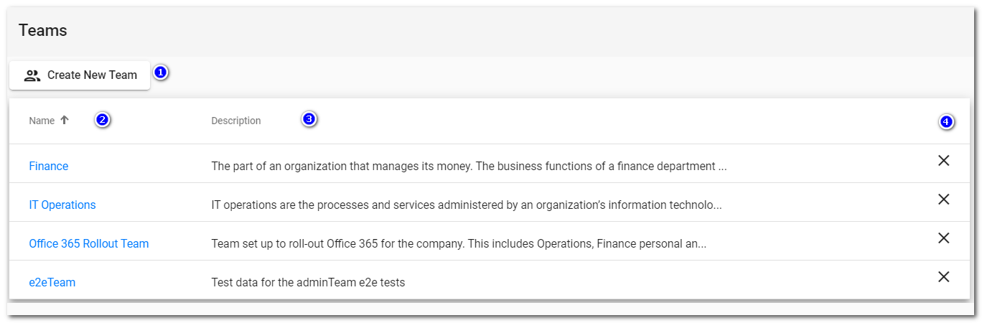

1. Click to create a new team.
2. Name – Sortable list of teams by their names. Click on the name to open the team edit panel to update the team name and description.
3. Description of the team
4. Delete – use this to delete a team, you will be asked to confirm the deletion before it can occur.

### Manage DARs

The administrator has special rights to manage DARs. They can see all DARs in the system, update DAR information, export DARs, and logically delete DARs. Use of this function should be an exception rather than a normal part of the workflow. An example of where this could be needed is when a DAR owner leaves the company and a new one needs to be assigned.

See the DAR listing below which is the starting point for DAR management.

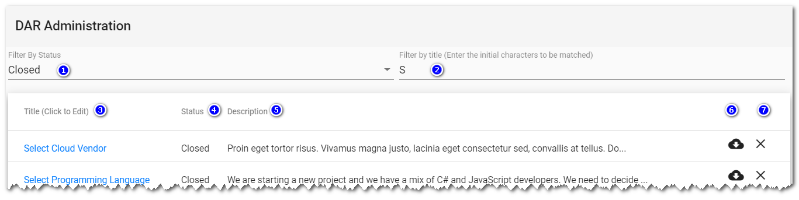

The listing has one line for each DAR in the system (Only the first 100 DARs are retrieved so use the filter options if the DAR is not found)

1. Filter by Status – Show only DARs with the matching status (All shows all DARs)
2. Filter by Title – Only show DARs that have matching initial characters in the title, blank will show all DARs. (Note: The title match is case sensitive)
3. DAR Ditle – The title of the DAR. Click on the DAR title to be taken to the DAR form to perform updates. There a few restrictions on what an administrator can update on a DAR, be careful.
4. Status – The current status of the DAR.
5. Description – The DAR description (sortable)
6. Export – click to be taken to the DAR export function (See Import/Export DARs).
7. Delete – Use this to delete (Logically) the DAR. The administrator will be taken to the DAR form with the option to confirm the delete.

### Import/Export DARS

An administrator can export and import DARs. This is useful for sharing DARs , duplication DARs and loading/saving DAR information to other systems. Only one DAR can be exported/imported at a time. A DAR export is triggered by clicking on the export icon in the DAR Listing (See above).

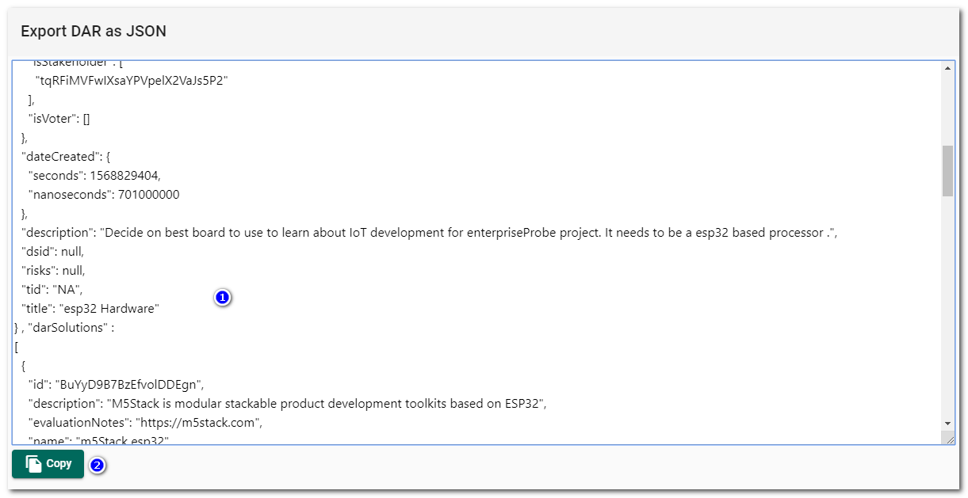

The resulting DAR export interface is shown above.

1. The DAR export information is presented in a text box in JSON format.
2. The user can copy the DAR JSON to their clipboard. This can then be pasted as JSON to another application like notepad to save as a file (Or past the JSON into another JSON aware application for additional processing).

The DAR JSON can be imported into the system as a new DAR by using the DAR Import option on the administration menu. The DAR import form is shown below.

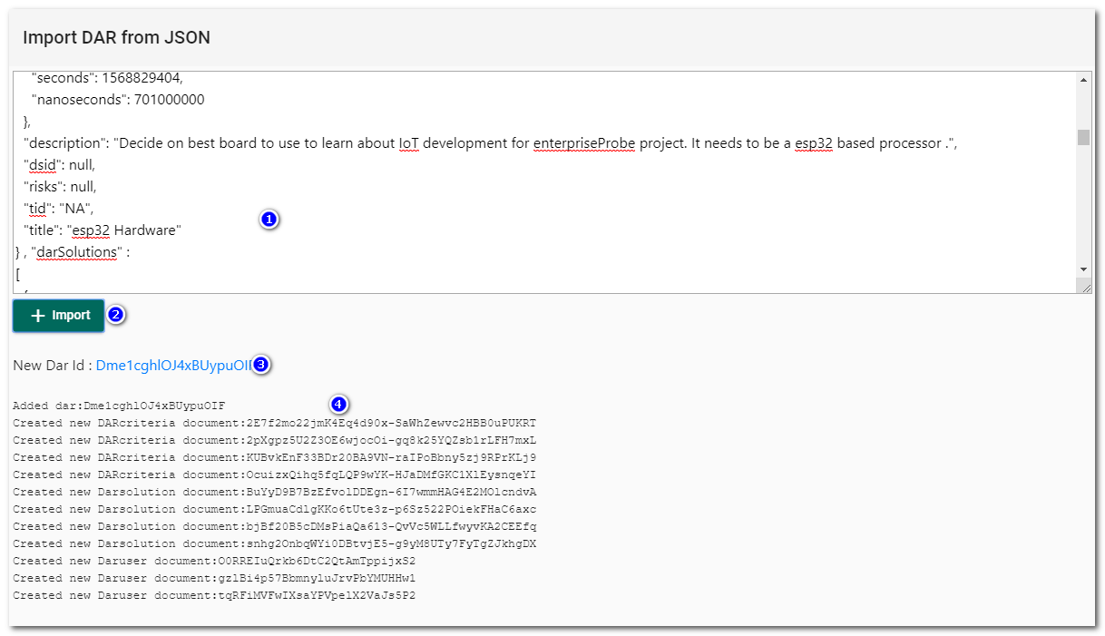

1. DAR JSON – this is a text box where the DAR JSON can be pasted.
2. Import – This button will initiate the verification and import of the DAR , note the DAR will only be imported if it is a valid DAR JSON. Any JSON validation errors will be shown.
3. The results of the DAR import, if successful a link is provided to the DAR Viewer for the new DAR. Note: Imported DARs’ titles are suffixed with the wording (Copy). All DAR documents are assigned new IDs to prevent clashes with existing DAR documents.
4. Details about documents created including the old and new document IDs.

## Technical

### Data (Firestore Document Model)

### Security

Firestore security rules can be found in the projects Firestore.rules file. Below is the high level (Document level) rules in that file that controls access to the Firestore instance and documents.

function isValidNextDarStatus() {

// design -> vote or evaluate

// vote -> confirm or design

// evaluate -> confirm or vote or design

// confirm -> close or design

//return true;

// Note: Could also tighten up by using methodology but probably overkill (You have to be dar owner at least to do any weird workflows)

return (resource.data.darStatus == dsDesign() && (request.resource.data.darStatus == dsEvaluate() || request.resource.data.darStatus == dsVote() )) ||

(resource.data.darStatus == dsVote() && (request.resource.data.darStatus == dsConfirm() || request.resource.data.darStatus == dsDesign() )) ||

(resource.data.darStatus == dsEvaluate() && (request.resource.data.darStatus == dsVote() || request.resource.data.darStatus == dsConfirm() || request.resource.data.darStatus == dsDesign())) ||

(resource.data.darStatus == dsConfirm() && (request.resource.data.darStatus == dsClosed() || request.resource.data.darStatus == dsDesign() )) ;

}

// ****** Document Access Rules

// user document rules (Delete not allowed)

// 1 Own user document: read/write (except for updates to isAdmin and isActivated properties)

// special case is create

match /users/{user} {

allow read , create: if isAuthenticated() &&

user==request.auth.uid ;

allow update: if isAuthenticated() &&

user==request.auth.uid &&

request.resource.data.isAdmin == resource.data.isAdmin &&

request.resource.data.isActivated == resource.data.isActivated;

}

// 2 isAdmin : Other user documents can read and write

// Note: Stonger read security may be needed if the user information

// is to be locked down (i.e. only let users who are dar owners in the system to do reads.)

match /users/{user} {

allow read: if isAuthenticated();

allow write: if isAdmin() &&

user!=request.auth.uid ;

}

// Team document rules

//

match /teams/{team} {

allow read: if isAuthenticated();

allow write: if isAdmin() ;

}

// Dars document rules

// !!!Add more conditions about status

match /dars/{dar} {

allow read: if isAuthenticated();

allow update: if isAdmin() ||

(isDarOwner(dar) && isDarStatus(dar,dsDesign())) ||

(isDarOwner(dar) && isDarDSIDUpdate() && (isDarStatus(dar,dsEvaluate()) || isDarStatus(dar,dsVote()))) ||

(isDarOwner(dar) && isDarStatusUpdate() && isValidNextDarStatus()) ;

allow create: if isAdmin() || isDarCreator();

allow delete: if isAdmin();

}

// darsolutions document rules

//

match /dars/{dar}/darSolutions/{dsid} {

allow read: if isAuthenticated();

allow write: if isDarOwner(dar) || isAdmin()

}

// darCriteria document rules

//

match /dars/{dar}/darCriteria/{dcid} {

allow read: if isAuthenticated();

allow write: if isDarOwner(dar) || isAdmin()

}

// darUsers document rules

//

match /dars/{dar}/darUsers/{duid} {

allow read: if isAuthenticated();

allow update: if (isDarOwner(dar) ||

isAdmin() ||

(isDarUserConfirmationUpdate() && isDarStakeholder(dar) && isDarStatus(dar,dsConfirm())) ||

(isDarUserVoteUpdate() && isDarVoter(dar) && isDarStatus(dar,dsVote()))

)

allow create: if isDarOwner(dar) || isAdmin() || isDarCreator();

allow delete: if isDarOwner(dar) || isAdmin();

}

// darEvaluations document rules

//

match /dars/{dar}/darSolutions/{dsid}/darEvaluations/{dcid} {

allow read: if isAuthenticated();

allow update: if isAdmin() || (isDarEvaluator(dar) && isDarStatus(dar,dsEvaluate())) ;

allow create: if isAdmin() || (isDarEvaluator(dar) && isDarStatus(dar,dsEvaluate())) ;

allow delete: if isAdmin() ;

}

// for the subcollection index

match /{path=**}/darEvaluations/{dcid} {

allow read: if isAuthenticated();

}

### Evaluation Score Calculation

The table below shows the scoring given to a solution based on the criteria importance and the evaluation score. Changes to this scoring can be made in the ourDars darViewEvaluation.component.ts file, in the calculateCellScore function.

|  |  |  |  |
| --- | --- | --- | --- |
|  | Critical | Important | Desirable |
| Fully Met | 8 | 5 | 1 |
| Met | 4 | 4 | 1 |
| Met with Conditions | 2 | 3 | 1 |
| Partially Met | 0 | 1 | 0 |
| Not Met | 0 | 0 | 0 |

Note: The special case of a “Critical” criteria that is “Not Met” will score zero but will also raise an alert on the DAR views. This can be a special case where a solution is rejected just for this reason, without regard to the resulting score for other criteria.

### CMMI DAR Process Area

Taken from: <https://resources.sei.cmu.edu/asset_files/TechnicalReport/2010_005_001_15287.pdf> . Go to the source document for more information on the full DAR process area and CMMI.

*DECISION ANALYSIS AND RESOLUTION*

*A Support Process Area at Maturity Level 3*

***Purpose***

*The purpose of Decision Analysis and Resolution (DAR) is to analyze possible decisions using a formal evaluation process that evaluates identified alternatives against established criteria.*

***Introductory Notes***

*The Decision Analysis and Resolution process area involves establishing guidelines to determine which issues should be subject to a formal evaluation process and applying formal evaluation processes to these issues.*

*A formal evaluation process is a structured approach to evaluating alternative solutions against established criteria to determine a recommended solution.*

*A formal evaluation process involves the following actions:*

* *Establishing the criteria for evaluating alternatives*
* *Identifying alternative solutions*
* *Selecting methods for evaluating alternatives*
* *Evaluating alternative solutions using established criteria and methods*
* *Selecting recommended solutions from alternatives based on evaluation criteria*

*Rather than using the phrase “alternative solutions to address issues” each time, in this process area, one of two shorter phrases are used: “alternative solutions” or “alternatives.”*

*A formal evaluation process reduces the subjective nature of a decision and provides a higher probability of selecting a solution that meets multiple demands of relevant stakeholders.*

*While the primary application of this process area is to technical concerns, formal evaluation processes can be applied to many nontechnical issues, particularly when a project is being planned. Issues that have multiple alternative solutions and evaluation criteria lend themselves to a formal evaluation process.*

*During planning, specific issues requiring a formal evaluation process are identified. Typical issues include selection among architectural or design alternatives, use of reusable or commercial off-the-shelf (COTS) components, supplier selection, engineering support environments or CMMI for Development, Version 1.3 150 Decision Analysis and Resolution (DAR) associated tools, test environments, delivery alternatives, and logistics and production. A formal evaluation process can also be used to address a make-or-buy decision, the development of manufacturing processes, the selection of distribution locations, and other decisions.*

*Guidelines are created for deciding when to use formal evaluation processes to address unplanned issues. Guidelines often suggest using formal evaluation processes when issues are associated with medium-tohigh-impact risks or when issues affect the ability to achieve project objectives.*

*Defining an issue well helps to define the scope of alternatives to be considered. The right scope (i.e., not too broad, not too narrow) will aid in making an appropriate decision for resolving the defined issue.*

*Formal evaluation processes can vary in formality, type of criteria, and methods employed. Less formal decisions can be analyzed in a few hours, use few criteria (e.g., effectiveness, cost to implement), and result in a one or two-page report. More formal decisions can require separate plans, months of effort, meetings to develop and approve criteria, simulations, prototypes, piloting, and extensive documentation.*

*Both numeric and non-numeric criteria can be used in a formal evaluation process. Numeric criteria use weights to reflect the relative importance of criteria. Non-numeric criteria use a subjective ranking scale (e.g., high, medium, low). More formal decisions can require a full trade study.*

*A formal evaluation process identifies and evaluates alternative solutions. The eventual selection of a solution can involve iterative activities of identification and evaluation. Portions of identified alternatives can be combined, emerging technologies can change alternatives, and the business situation of suppliers can change during the evaluation period.*

*A recommended alternative is accompanied by documentation of selected methods, criteria, alternatives, and rationale for the recommendation. The documentation is distributed to relevant stakeholders; it provides a record of the formal evaluation process and rationale, which are useful to other projects that encounter a similar issue.*

*While some of the decisions made throughout the life of the project involve the use of a formal evaluation process, others do not. As mentioned earlier, guidelines should be established to determine which issues should be subject to a formal evaluation process.*

*… (See original document for more details of practices and examples)*